**Library DBMS**

**Objective:** To make a program for Library database management system.

**Preface of Code:**

The program has a total of 10 functionalities for performing on the library database containing book number, book name, book issue date, book return date and the student id of the student who has the book issued. 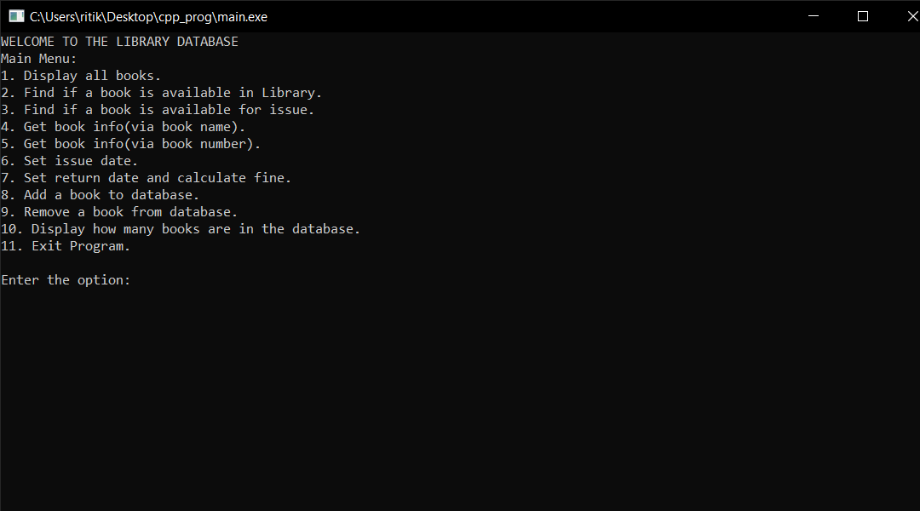

The database has been grabbed by a “book_list.txt” file.

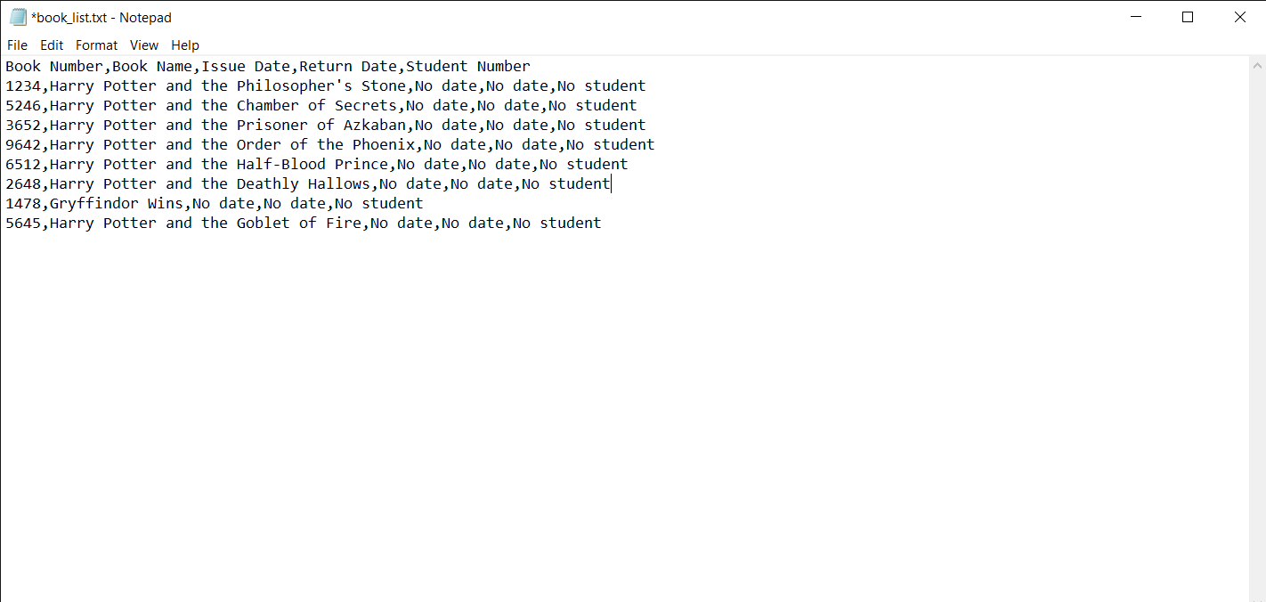

In the database any two books can have the same name but not the same book number. Moreover the functions to be performed are of two types: the first type are available for all such as the functions 1,2,3,4,5 and 10. The second type of function are password protected and can be available to only the ones having the password. The password can be changed by changing the value of passer string on line 13. The current password is “123”. The functions are as follows:

1. Display all books:

The function simply displays all books available in the database.

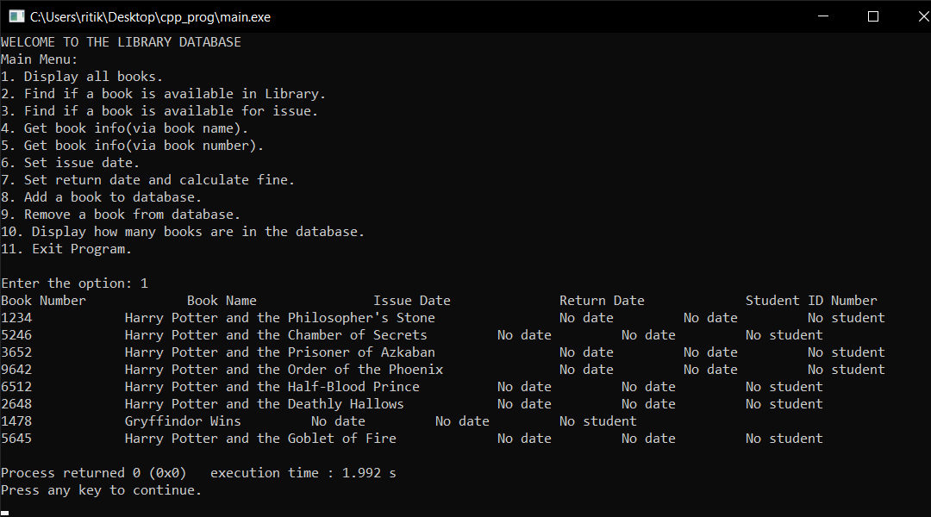

1. Find if a book is available in library:

This function takes the book name as input and returns the output stating if the book is in the library database or not.

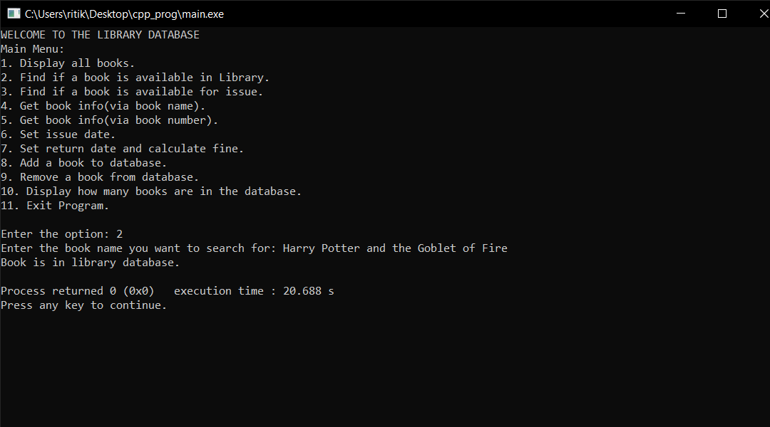

1. Find if a book is available for issue:

The function much like the previous one takes the name of the book as argument and displays the info about any book with the same name which is available for issue.

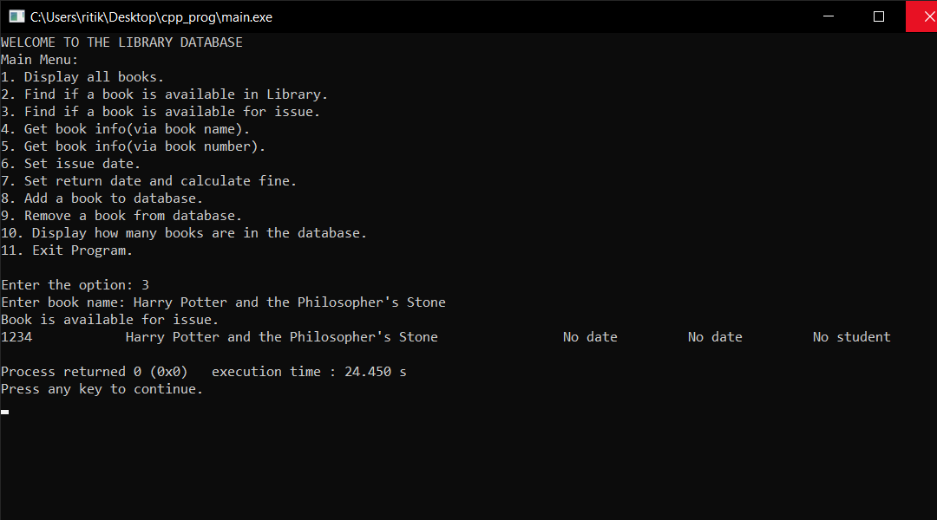

1. Get book info(via book name):

Displays information about the book given it’s name.

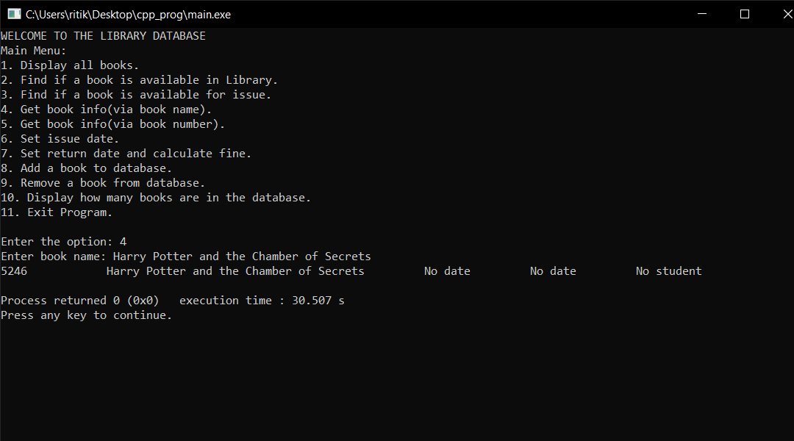

1. Get book info(via book number):

Displays information about the book given the book number.

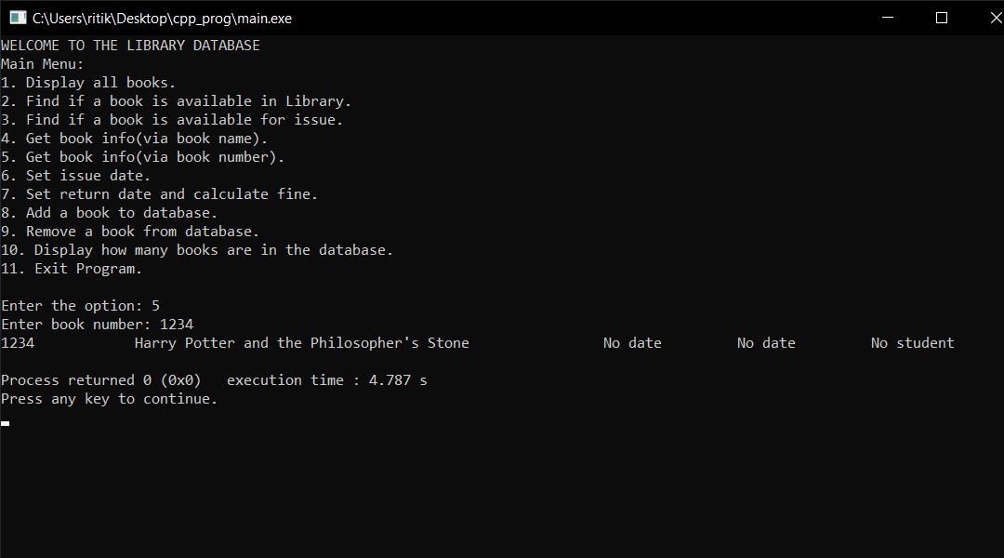

1. Set issue date:

The function is password protected and lets the user input the issue date of the book and has to be provided with the book number, issue date and the student id.

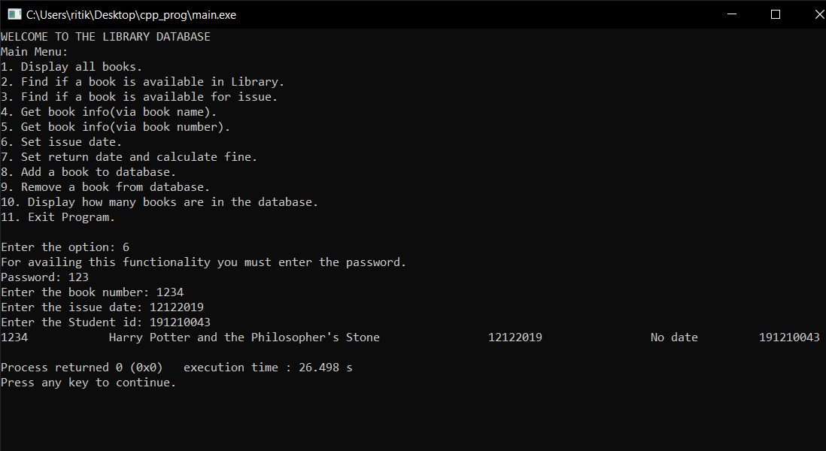

1. Set return date and calculate fine:

This function also password protected asks for the book number and the return date and outputs the fine. The number of days till when the fine is exempted is initially set to 7 and can be edited on line 22 and the the fine per day which is set to 1 can be edited on line 21.

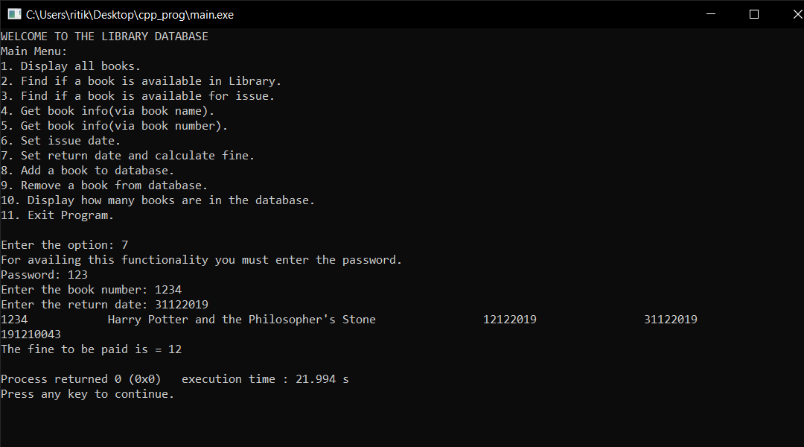

1. Add a book to database:

This password protect function asks for the book number and the book name.

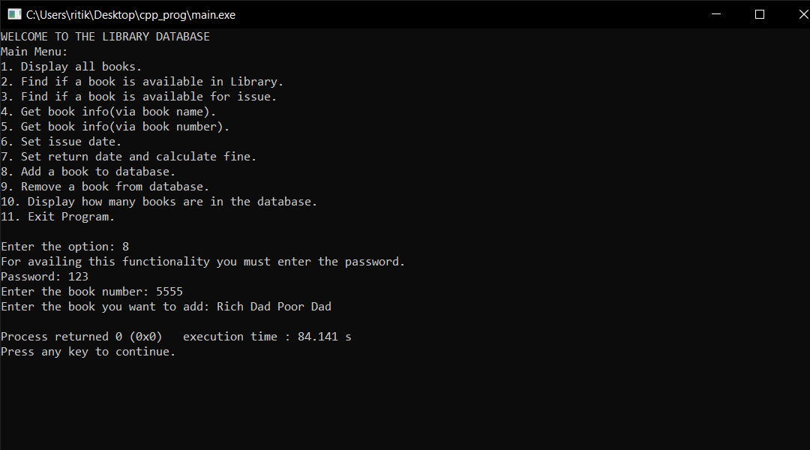

And as we can we can see the new book has been added.

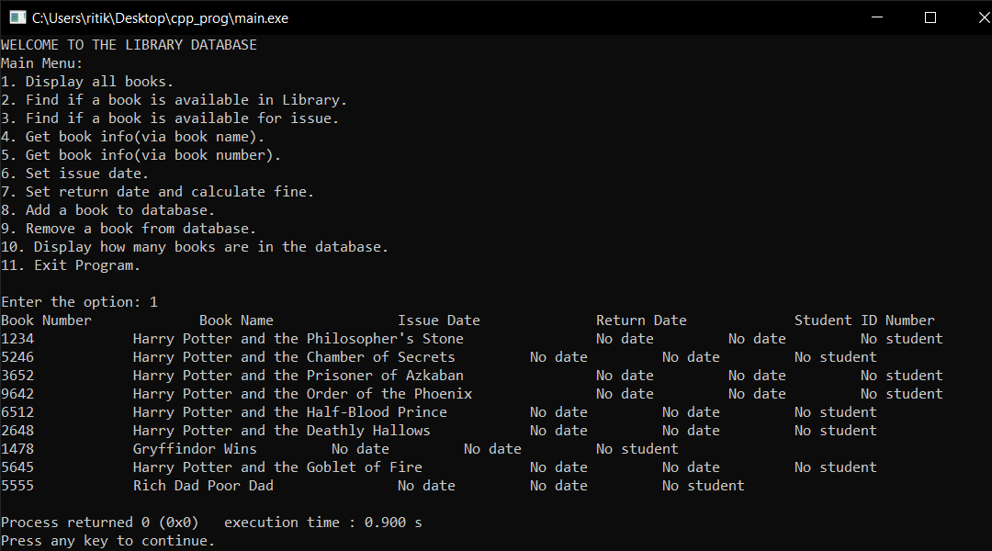

1. Remove a book from database:

The password protected function asks for only the book number of the book.

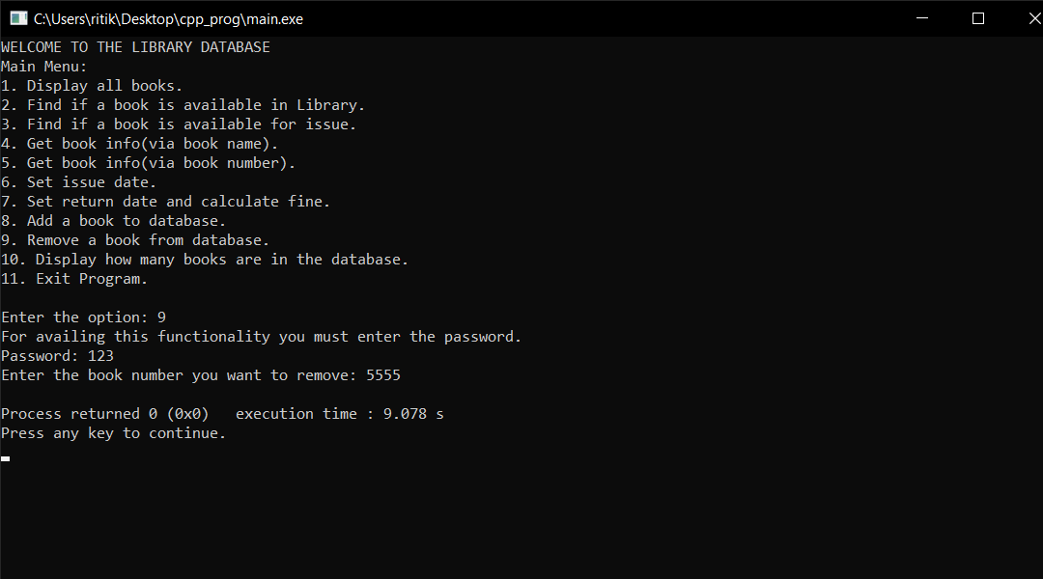

And as seen next the book has been removed from the database.

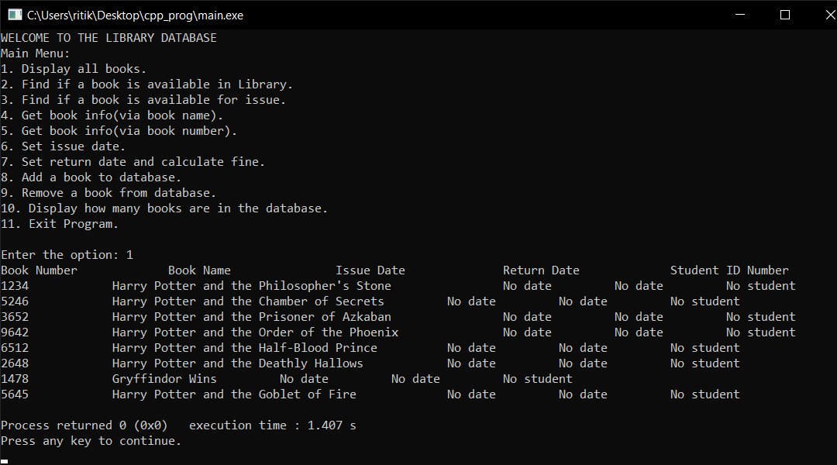

1. Display how many books are available in the database:

Simply provides the number of books in the database.

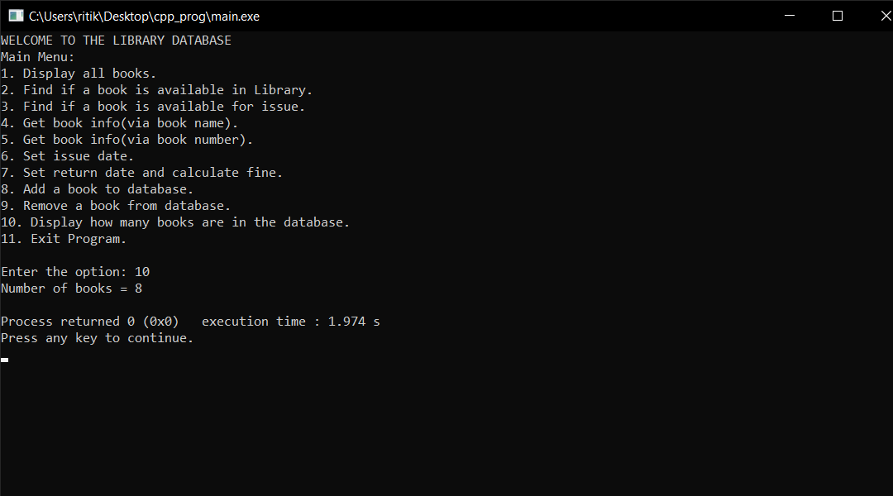

The changes in the database are stored in the same file every-time the program runs till the end.

**Pogram Code:**

#include <iostream>

#include <bits/stdc++.h>

#include <vector>

#include <fstream>

#include <string.h>

#include <string>

#include <sstream>

#include <math.h>

using namespace std;

const int code=123;

const string passer="123";

string file="book_list.txt";

string bno,bn,idate,rdate,sno;

std::vector<std::string> b_no;

std::vector<std::string> b_n;

std::vector<std::string> i_d;

std::vector<std::string> r_d;

std::vector<std::string> s_n;

int f=1;//fine per day

int d=7;//exemption of fine for how many days

void find_if_available();

void display_all_books();

void get_info_wname();

void get_info_wno();

void for_issue();

void display_size();

void set_rd();

void set_id();

void add_to_fine(string stu, int fine);

void book_remove();

int calculate_fine(string idate,string rdate);

void book_add();

int rdn(int y, int m, int d){

if(m<3)

y--,m+=12;

return 365*y +y/4 - y/100 + y/400 + (153*m-457)/5 + d - 306;

}

int main()

{

int i=0;

ifstream fileio(file);

if(fileio.is_open())

{

string line;

getline(fileio,line);

while(!fileio.eof())

{

getline(fileio,bno,',');

b_no.push_back(bno);

getline(fileio,bn,',');

b_n.push_back(bn);

getline(fileio,idate,',');

i_d.push_back(idate);

getline(fileio,rdate,',');

r_d.push_back(rdate);

getline(fileio,sno,'\n');

s_n.push_back(sno);

i+=1;

}

fileio.close();

}

else

cout<<"Unable to open file"<<endl;

i_d.erase(i_d.end());

r_d.erase(r_d.end());

b_no.erase(b_no.end());

b_n.erase(b_n.end());

s_n.erase(s_n.end());

cout<<"WELCOME TO THE LIBRARY DATABASE"<<endl;

cout<<"Main Menu:\n";

cout<<"1. Display all books.\n";

cout<<"2. Find if a book is available in Library.\n";

cout<<"3. Find if a book is available for issue.\n";

cout<<"4. Get book info(via book name).\n";

cout<<"5. Get book info(via book number).\n";

cout<<"6. Set issue date.\n";

cout<<"7. Set return date and calculate fine.\n";

cout<<"8. Add a book to database.\n";

cout<<"9. Remove a book from database.\n";

cout<<"10. Display how many books are in the database.\n";

cout<<"11. Exit Program.\n";

cout<<"\n";

int passcode=123;

int option;

cout<<"Enter the option: ";

cin>>option;

switch(option)

{

case 1:

display_all_books();

break;

case 2:

find_if_available();

break;

case 3:

for_issue();

break;

case 4:

get_info_wname();

break;

case 5:

get_info_wno();

break;

case 6:

set_id();

break;

case 7:

set_rd();

break;

case 8:

book_add();

break;

case 9:

book_remove();

break;

case 10:

display_size();

break;

case 11:

break;

default:

cout<<"You input an invalid option."<<endl;

}

//writing in file

std::ofstream outfile(file);

outfile<<"Book Number,Book Name,Issue Date,Return Date,Student ID Number\n";

for(int j=0;j<b_n.size();j++)

{

outfile<<b_no[j]<<","<<b_n[j]<<","<<i_d[j]<<","<<r_d[j]<<","<<s_n[j]<<"\n";

}

}

void book_add()

{

cout<<"For availing this functionality you must enter the password."<<endl;

cout<<"Password: ";

string pass;

cin>>pass;

if(!pass.compare(passer))

{

string n;

cout<<"Enter the book number: ";

cin.ignore();

getline(cin,n);

int flag=0;

for(int j=0;j<b_n.size();j++)

{

if(!n.compare(b_no[j]))

{

flag+=1;

break;

}

}

if(flag!=0)

{

cout<<"This book number already exists."<<endl;

return ;

}

else

{

string q;

cout<<"Enter the book you want to add: ";

getline(cin,q);

b_no.push_back(n);

b_n.push_back(q);

i_d.push_back("No date");

r_d.push_back("No date");

s_n.push_back("No student");

}

}

else

{

cout<<"Wrong password."<<endl;

cout<<"This functionality is not available to you."<<endl;

}

}

void book_remove()

{

cout<<"For availing this functionality you must enter the password."<<endl;

cout<<"Password: ";

string pass;

cin>>pass;

if(!pass.compare(passer))

{

string n;

cout<<"Enter the book number you want to remove: ";

cin>>n;

//string q;

//cout<<"Enter the book name you want to remove: ";

//getline(cin,q);

int flag=0;

for(int j=0;j<b_n.size();j++)

{

if(!n.compare(b_no[j]))

{

b_no.erase(b_no.begin()+j);

b_n.erase(b_n.begin()+j);

i_d.erase(i_d.begin()+j);

r_d.erase(r_d.begin()+j);

s_n.erase(s_n.begin()+j);

flag+=1;

break;

}

}

if(flag==0)

{

cout<<"Book is not available in library database."<<endl;

}

}

else

{

cout<<"Wrong password."<<endl;

cout<<"This functionality is not available to you."<<endl;

}

}

int calculate_fine(string idate,string rdate)

{

int rd=stoi(rdate);

int id=stoi(idate);

int d2=rd/1000000;

int m2=rd/10000 - d2*100;

int y2=rd - m2*10000 - d2*1000000;

int d1=id/1000000;

int m1=id/10000 - d1*100;

int y1=id - m1*10000 - d1*1000000;

int diff = rdn(y2,m2,d2) - rdn(y1,m1,d1);

int fine=0;

if(diff>d)

{

fine+=(diff-d)*f;

}

cout<<"The fine to be paid is = "<<fine<<endl;

}

void set_rd()

{

cout<<"For availing this functionality you must enter the password."<<endl;

cout<<"Password: ";

string pass;

cin>>pass;

if(!pass.compare(passer))

{

string n,idate;

cout<<"Enter the book number: ";

cin>>n;

int flag=0;

int j;

for(j=0;j<b_n.size();j++)

{

if(!n.compare(b_no[j]))

{

if(i_d[j].compare("No date"))

{

cout<<"Enter the return date: ";

cin>>idate;

r_d[j]=idate;

cout<<b_no[j]<<"\t\t"<<b_n[j]<<"\t\t"<<i_d[j]<<"\t\t"<<r_d[j]<<"\t\t"<<s_n[j]<<endl;

flag+=1;

string student=s_n[j];

int fine = calculate_fine(i_d[j],r_d[j]);

i_d[j]="No date";

r_d[j]="No date";

s_n[j]="No student";

break;

}

else

{

cout<<"Book is not available for return as it has not been issued yet."<<endl;

flag+=1;

}

}

}

if(flag==0)

{

cout<<"Book is not available in library database."<<endl;

}

}

else

{

cout<<"Wrong Password."<<endl;

cout<<"This functionality is not available to you."<<endl;

}

}

void display_size()

{

int j;

for(j=0;j<i_d.size();j++)

{

j+=1;

}

cout<<"Number of books = "<<j<<endl;

}

void for_issue()

{

string q;

cout<<"Enter book name: ";

cin.ignore();

getline(cin,q);

int flag=0;

int ctr=0;

for(int j=0;j<b_n.size();j++)

{

if(!q.compare(b_n[j]))

{

if(!i_d[j].compare("No date"))

{

cout<<"Book is available for issue."<<endl;

cout<<b_no[j]<<"\t\t"<<b_n[j]<<"\t\t"<<i_d[j]<<"\t\t"<<r_d[j]<<"\t\t"<<s_n[j]<<endl;

flag+=1;

ctr+=1;

}

else

{

flag+=1;

}

}

}

if(flag==0)

cout<<"No such book is in library database."<<endl;

else if(flag!=0 && ctr==0)

cout<<"Book is not available for issue."<<endl;

}

void set_id()

{

cout<<"For availing this functionality you must enter the password."<<endl;

cout<<"Password: ";

string pass;

cin>>pass;

if(!pass.compare(passer))

{

string book,idate;

cout<<"Enter the book number: ";

cin>>book;

int flag=0;

for(int j=0;j<b_n.size();j++)

{

if(!book.compare(b_no[j]))

{

if(!i_d[j].compare("No date"))

{

cout<<"Enter the issue date: ";

cin>>idate;

i_d[j]=idate;

string s_no;

cout<<"Enter the Student id: ";

cin>>s_no;

s_n[j]=s_no;

cout<<b_no[j]<<"\t\t"<<b_n[j]<<"\t\t"<<i_d[j]<<"\t\t"<<r_d[j]<<"\t\t"<<s_n[j]<<endl;

flag+=1;

break;

}

else

{

cout<<"Book is not available for issue."<<endl;

flag+=1;

}

}

}

if(flag==0)

{

cout<<"Book is not available in library database."<<endl;

}

}

else

{

cout<<"Wrong password."<<endl;

cout<<"This functionality is not available to you."<<endl;

}

}

void get_info_wname()

{

string book;

cout<<"Enter book name: ";

cin.ignore();

getline(cin,book);

int flag=0;

for(int j=0;j<b_n.size();j++)

{

if(!book.compare(b_n[j]))

{

cout<<b_no[j]<<"\t\t"<<b_n[j]<<"\t\t"<<i_d[j]<<"\t\t"<<r_d[j]<<"\t\t"<<s_n[j]<<endl;

flag+=1;

}

}

if(flag==0)

cout<<"Book is not available in library database."<<endl;

}

void get_info_wno()

{

cout<<"Enter book number: ";

string book;

cin>>book;

int j=0;

int flag=0;

for(j=0;j<b_n.size();j++)

{

if(!book.compare(b_no[j]))

{

cout<<b_no[j]<<"\t\t"<<b_n[j]<<"\t\t"<<i_d[j]<<"\t\t"<<r_d[j]<<"\t\t"<<s_n[j]<<endl;

flag+=1;

break;

}

}

if(flag==0)

cout<<"Book is not available in library database."<<endl;

}

void find_if_available()

{

cout<<"Enter the book name you want to search for: ";

string q;

cin.ignore();

getline(cin,q);

int flag=0;

for(int j=0;j<b_n.size();j++)

{

if(!q.compare(b_n[j]))

{

cout<<"Book is in library database."<<endl;

flag=1;

break;

}

}

if(flag==0)

cout<<"Book is not available in library database."<<endl;

}

void display_all_books()

{

cout<<”Book Number\t\tBook Name\t\tIssue Date\t\tReturn Date\t\tStudent ID Number”

for(int j=0;j<b_n.size();j++)

{

cout<<b_no[j]<<"\t\t"<<b_n[j]<<"\t\t"<<i_d[j]<<"\t\t"<<r_d[j]<<"\t\t"<<s_n[j]<<endl;

}

}